**WEEK 4**

**Spring REST using Spring Boot 3 Hands-On Exercises**

1. spring-rest-handson

**Hands on 1**

**Create a Spring Web Project using Maven** 

**spring-learn/pom.xml**

<?xml version="1.0" encoding="UTF-8"?>

<project xmlns="http://maven.apache.org/POM/4.0.0" xmlns:xsi="http://www.w3.org/2001/XMLSchema-instance"

xsi:schemaLocation="http://maven.apache.org/POM/4.0.0 https://maven.apache.org/xsd/maven-4.0.0.xsd">

<modelVersion>4.0.0</modelVersion>

<parent>

<groupId>org.springframework.boot</groupId>

<artifactId>spring-boot-starter-parent</artifactId>

<version>3.5.3</version>

<relativePath/> <!-- lookup parent from repository -->

</parent>

<groupId>com.cognizant</groupId>

<artifactId>spring-learn</artifactId>

<version>0.0.1-SNAPSHOT</version>

<name>spring-learn</name>

<description>Demo project for Spring Boot</description>

<url/>

<licenses>

<license/>

</licenses>

<developers>

<developer/>

</developers>

<scm>

<connection/>

<developerConnection/>

<tag/>

<url/>

</scm>

<properties>

<java.version>17</java.version>

</properties>

<dependencies>

<dependency>

<groupId>org.springframework.boot</groupId>

<artifactId>spring-boot-starter-web</artifactId>

</dependency>

<dependency>

<groupId>org.springframework.boot</groupId>

<artifactId>spring-boot-devtools</artifactId>

<scope>runtime</scope>

<optional>true</optional>

</dependency>

<dependency>

<groupId>org.springframework.boot</groupId>

<artifactId>spring-boot-starter-test</artifactId>

<scope>test</scope>

</dependency>

</dependencies>

<build>

<plugins>

<plugin>

<groupId>org.springframework.boot</groupId>

<artifactId>spring-boot-maven-plugin</artifactId>

</plugin>

</plugins>

</build>

</project>

**SpringLearnAppicationTests.java**

**package** com.cognizant.spring_learn;

**import** org.junit.jupiter.api.Test;

**import** org.springframework.boot.test.context.SpringBootTest;

@SpringBootTest

**class** SpringLearnApplicationTests {

@Test

**void** contextLoads() {

}

}

**SpringLearnAppication.java**

**package** com.cognizant.springlearn;

**import** org.springframework.boot.SpringApplication;

**import** org.springframework.boot.autoconfigure.SpringBootApplication;

**import** org.slf4j.Logger;

**import** org.slf4j.LoggerFactory;

@SpringBootApplication

**public** **class** SpringLearnApplication {

**private** **static** **final** Logger ***LOGGER*** = LoggerFactory.*getLogger*(SpringLearnApplication.**class**);

**public** **static** **void** main(String[] args) {

***LOGGER***.info("Inside main");

SpringApplication.*run*(SpringLearnApplication.**class**, args);

}

}

**OUTPUT**

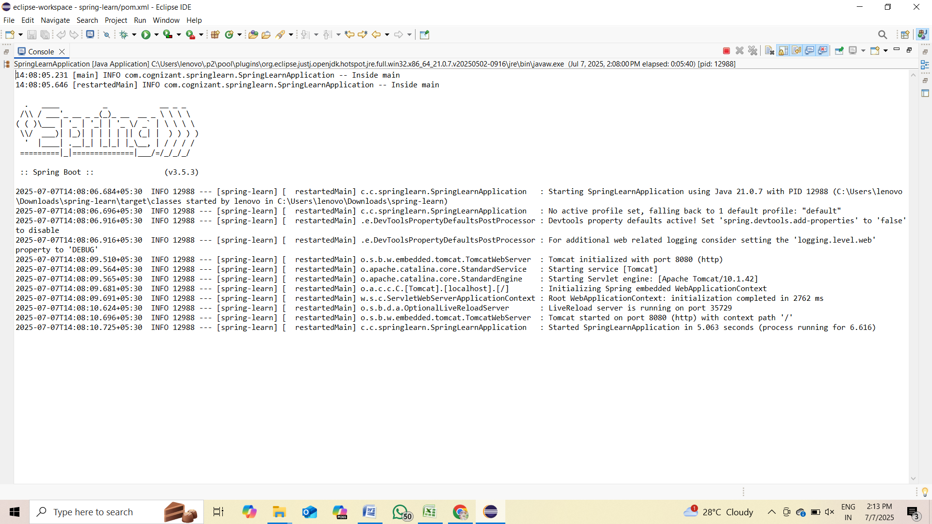

**Hands on 2**

**Spring Core – Load SimpleDateFormat from Spring Configuration XML**   
  
**spring-learn/pom.xml**

<?xml version="1.0" encoding="UTF-8"?>

<project xmlns="http://maven.apache.org/POM/4.0.0" xmlns:xsi="http://www.w3.org/2001/XMLSchema-instance"

xsi:schemaLocation="http://maven.apache.org/POM/4.0.0 https://maven.apache.org/xsd/maven-4.0.0.xsd">

<modelVersion>4.0.0</modelVersion>

<parent>

<groupId>org.springframework.boot</groupId>

<artifactId>spring-boot-starter-parent</artifactId>

<version>3.5.3</version>

<relativePath/> <!-- lookup parent from repository -->

</parent>

<groupId>com.cognizant</groupId>

<artifactId>spring-learn</artifactId>

<version>0.0.1-SNAPSHOT</version>

<name>spring-learn</name>

<description>Demo project for Spring Boot</description>

<url/>

<licenses>

<license/>

</licenses>

<developers>

<developer/>

</developers>

<scm>

<connection/>

<developerConnection/>

<tag/>

<url/>

</scm>

<properties>

<java.version>17</java.version>

</properties>

<dependencies>

<dependency>

<groupId>org.springframework.boot</groupId>

<artifactId>spring-boot-starter-web</artifactId>

</dependency>

<dependency>

<groupId>org.springframework.boot</groupId>

<artifactId>spring-boot-devtools</artifactId>

<scope>runtime</scope>

<optional>true</optional>

</dependency>

<dependency>

<groupId>org.springframework.boot</groupId>

<artifactId>spring-boot-starter-test</artifactId>

<scope>test</scope>

</dependency>

</dependencies>

<build>

<plugins>

<plugin>

<groupId>org.springframework.boot</groupId>

<artifactId>spring-boot-maven-plugin</artifactId>

</plugin>

</plugins>

</build>

</project>

**SpringLearnAppicationTests.java**

**package** com.cognizant.spring_learn;

**import** org.junit.jupiter.api.Test;

**import** org.springframework.boot.test.context.SpringBootTest;

@SpringBootTest

**class** SpringLearnApplicationTests {

@Test

**void** contextLoads() {

}

}

**date-format.xml**

<?xml version="1.0" encoding="UTF-8"?>

<beans xmlns="http://www.springframework.org/schema/beans"

xmlns:xsi="http://www.w3.org/2001/XMLSchema-instance"

xsi:schemaLocation="

http://www.springframework.org/schema/beans

https://www.springframework.org/schema/beans/spring-beans.xsd">

<bean id="dateFormat" class="java.text.SimpleDateFormat">

<constructor-arg value="dd/MM/yyyy" />

</bean>

</beans>

**SpringLearnAppication.java**

**package** com.cognizant.springlearn;

**import** java.text.ParseException;

**import** java.text.SimpleDateFormat;

**import** java.util.Date;

**import** org.slf4j.Logger;

**import** org.slf4j.LoggerFactory;

**import** org.springframework.boot.SpringApplication;

**import** org.springframework.boot.autoconfigure.SpringBootApplication;

**import** org.springframework.context.ApplicationContext;

**import** org.springframework.context.support.ClassPathXmlApplicationContext;

@SpringBootApplication

**public** **class** SpringLearnApplication {

**private** **static** **final** Logger ***LOGGER*** = LoggerFactory.*getLogger*(SpringLearnApplication.**class**);

**public** **static** **void** main(String[] args) {

***LOGGER***.info("Inside main");

SpringApplication.*run*(SpringLearnApplication.**class**, args);

*displayDate*();

}

**public** **static** **void** displayDate() {

ApplicationContext context = **new** ClassPathXmlApplicationContext("date-format.xml");

SimpleDateFormat format = context.getBean("dateFormat", SimpleDateFormat.**class**);

**try** {

Date date = format.parse("31/12/2018");

System.***out***.println("Parsed Date: " + date);

} **catch** (ParseException e) {

e.printStackTrace();

}

}

}

**OUTPUT**

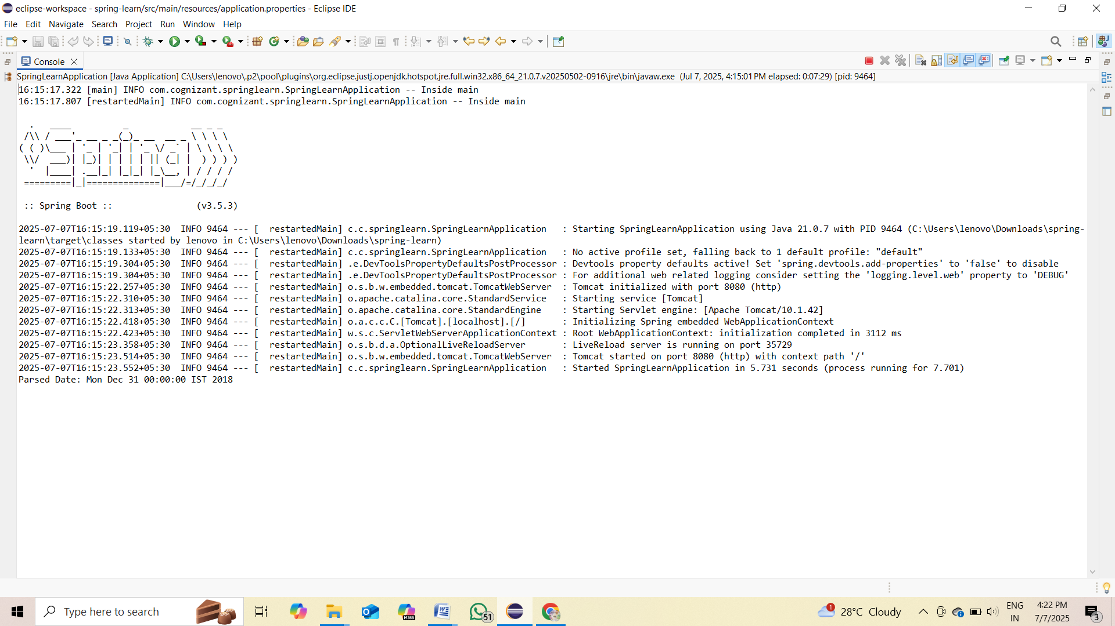

2. spring-rest-handson

**Hands on**

**Hello World RESTful Web Service**   
  
**spring-learn/pom.xml**

<?xml version="1.0" encoding="UTF-8"?>

<project xmlns="http://maven.apache.org/POM/4.0.0" xmlns:xsi="http://www.w3.org/2001/XMLSchema-instance"

xsi:schemaLocation="http://maven.apache.org/POM/4.0.0 https://maven.apache.org/xsd/maven-4.0.0.xsd">

<modelVersion>4.0.0</modelVersion>

<parent>

<groupId>org.springframework.boot</groupId>

<artifactId>spring-boot-starter-parent</artifactId>

<version>3.5.3</version>

<relativePath/> <!-- lookup parent from repository -->

</parent>

<groupId>com.cognizant</groupId>

<artifactId>spring-learn</artifactId>

<version>0.0.1-SNAPSHOT</version>

<name>spring-learn</name>

<description>Demo project for Spring Boot</description>

<url/>

<licenses>

<license/>

</licenses>

<developers>

<developer/>

</developers>

<scm>

<connection/>

<developerConnection/>

<tag/>

<url/>

</scm>

<properties>

<java.version>17</java.version>

</properties>

<dependencies>

<dependency>

<groupId>org.springframework.boot</groupId>

<artifactId>spring-boot-starter-web</artifactId>

</dependency>

<dependency>

<groupId>org.springframework.boot</groupId>

<artifactId>spring-boot-devtools</artifactId>

<scope>runtime</scope>

<optional>true</optional>

</dependency>

<dependency>

<groupId>org.springframework.boot</groupId>

<artifactId>spring-boot-starter-test</artifactId>

<scope>test</scope>

</dependency>

</dependencies>

<build>

<plugins>

<plugin>

<groupId>org.springframework.boot</groupId>

<artifactId>spring-boot-maven-plugin</artifactId>

</plugin>

</plugins>

</build>

</project>

**SpringLearnAppicationTests.java**

**package** com.cognizant.spring_learn;

**import** org.junit.jupiter.api.Test;

**import** org.springframework.boot.test.context.SpringBootTest;

@SpringBootTest

**class** SpringLearnApplicationTests {

@Test

**void** contextLoads() {

}

}

**date-format.xml**

<?xml version="1.0" encoding="UTF-8"?>

<beans xmlns="http://www.springframework.org/schema/beans"

xmlns:xsi="http://www.w3.org/2001/XMLSchema-instance"

xsi:schemaLocation="

http://www.springframework.org/schema/beans

https://www.springframework.org/schema/beans/spring-beans.xsd">

<bean id="dateFormat" class="java.text.SimpleDateFormat">

<constructor-arg value="dd/MM/yyyy" />

</bean>

</beans>

**SpringLearnAppication.java**

**package** com.cognizant.springlearn;

**import** java.text.ParseException;

**import** java.text.SimpleDateFormat;

**import** java.util.Date;

**import** org.slf4j.Logger;

**import** org.slf4j.LoggerFactory;

**import** org.springframework.boot.SpringApplication;

**import** org.springframework.boot.autoconfigure.SpringBootApplication;

**import** org.springframework.context.ApplicationContext;

**import** org.springframework.context.support.ClassPathXmlApplicationContext;

@SpringBootApplication

**public** **class** SpringLearnApplication {

**private** **static** **final** Logger ***LOGGER*** = LoggerFactory.*getLogger*(SpringLearnApplication.**class**);

**public** **static** **void** main(String[] args) {

***LOGGER***.info("Inside main");

SpringApplication.*run*(SpringLearnApplication.**class**, args);

*displayDate*();

}

**public** **static** **void** displayDate() {

ApplicationContext context = **new** ClassPathXmlApplicationContext("date-format.xml");

SimpleDateFormat format = context.getBean("dateFormat", SimpleDateFormat.**class**);

**try** {

Date date = format.parse("31/12/2018");

System.***out***.println("Parsed Date: " + date);

} **catch** (ParseException e) {

e.printStackTrace();

}

}

}

**HelloController.java**

**package** com.cognizant.springlearn.controller;

**import** org.slf4j.Logger;

**import** org.slf4j.LoggerFactory;

**import** org.springframework.web.bind.annotation.GetMapping;

**import** org.springframework.web.bind.annotation.RestController;

@RestController

**public** **class** HelloController {

**private** **static** **final** Logger ***LOGGER*** = LoggerFactory.*getLogger*(HelloController.**class**);

@GetMapping("/hello")

**public** String sayHello() {

***LOGGER***.info("START: sayHello()");

String message = "Hello World!!";

***LOGGER***.info("END: sayHello()");

**return** message;

}

}

**OUTPUT**

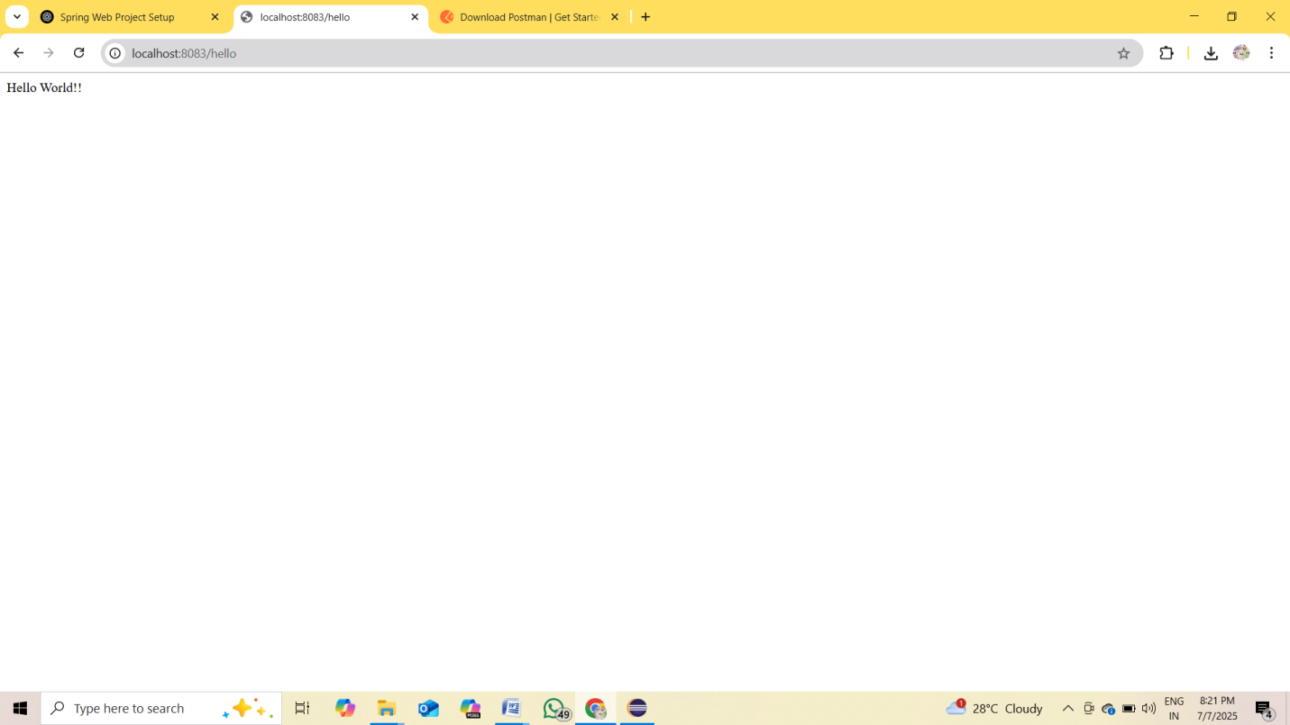

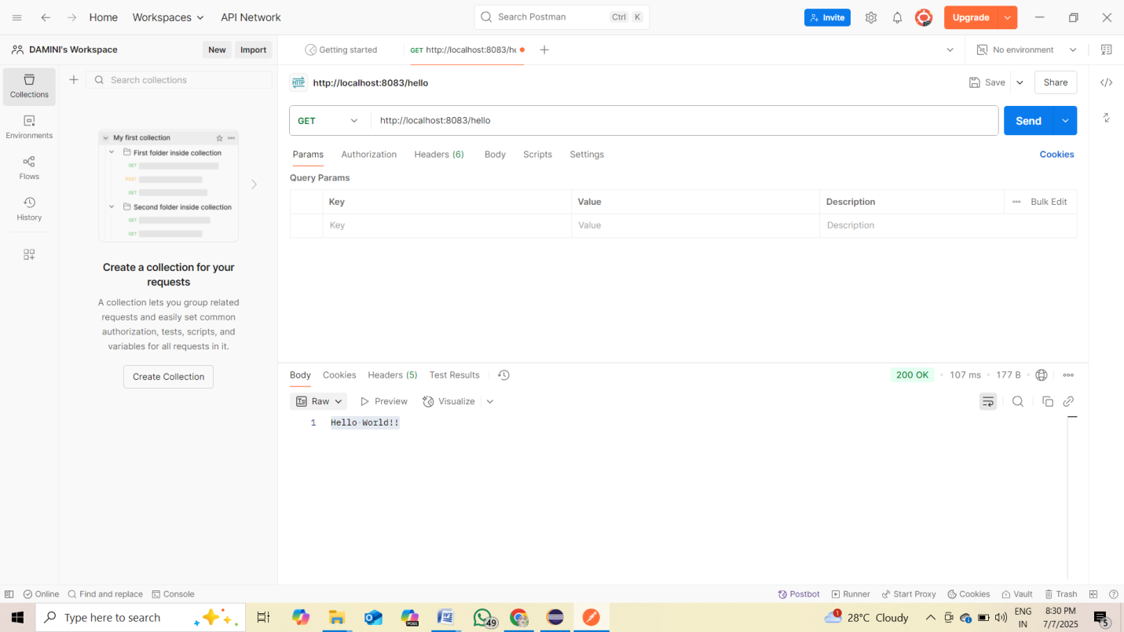

**Hands on**

**REST - Country Web Service**   
  
**spring-learn/pom.xml**

<?xml version="1.0" encoding="UTF-8"?>

<project xmlns="http://maven.apache.org/POM/4.0.0" xmlns:xsi="http://www.w3.org/2001/XMLSchema-instance"

xsi:schemaLocation="http://maven.apache.org/POM/4.0.0 https://maven.apache.org/xsd/maven-4.0.0.xsd">

<modelVersion>4.0.0</modelVersion>

<parent>

<groupId>org.springframework.boot</groupId>

<artifactId>spring-boot-starter-parent</artifactId>

<version>3.5.3</version>

<relativePath/> <!-- lookup parent from repository -->

</parent>

<groupId>com.cognizant</groupId>

<artifactId>spring-learn</artifactId>

<version>0.0.1-SNAPSHOT</version>

<name>spring-learn</name>

<description>Demo project for Spring Boot</description>

<url/>

<licenses>

<license/>

</licenses>

<developers>

<developer/>

</developers>

<scm>

<connection/>

<developerConnection/>

<tag/>

<url/>

</scm>

<properties>

<java.version>17</java.version>

</properties>

<dependencies>

<dependency>

<groupId>org.springframework.boot</groupId>

<artifactId>spring-boot-starter-web</artifactId>

</dependency>

<dependency>

<groupId>org.springframework.boot</groupId>

<artifactId>spring-boot-devtools</artifactId>

<scope>runtime</scope>

<optional>true</optional>

</dependency>

<dependency>

<groupId>org.springframework.boot</groupId>

<artifactId>spring-boot-starter-test</artifactId>

<scope>test</scope>

</dependency>

</dependencies>

<build>

<plugins>

<plugin>

<groupId>org.springframework.boot</groupId>

<artifactId>spring-boot-maven-plugin</artifactId>

</plugin>

</plugins>

</build>

</project>

**SpringLearnAppicationTests.java**

**package** com.cognizant.spring_learn;

**import** org.junit.jupiter.api.Test;

**import** org.springframework.boot.test.context.SpringBootTest;

@SpringBootTest

**class** SpringLearnApplicationTests {

@Test

**void** contextLoads() {

}

}

**country.xml**

<?xml version="1.0" encoding="UTF-8"?>

<beans xmlns="http://www.springframework.org/schema/beans"

xmlns:xsi="http://www.w3.org/2001/XMLSchema-instance"

xsi:schemaLocation="

http://www.springframework.org/schema/beans

https://www.springframework.org/schema/beans/spring-beans.xsd">

<!-- Existing dateFormat bean -->

<bean id="dateFormat" class="java.text.SimpleDateFormat">

<constructor-arg value="dd/MM/yyyy" />

</bean>

<!-- NEW Country bean -->

<bean id="country" class="com.cognizant.springlearn.model.Country">

<property name="code" value="IN" />

<property name="name" value="India" />

</bean>

</beans>

**SpringLearnAppication.java**

**package** com.cognizant.springlearn;

**import** java.text.ParseException;

**import** java.text.SimpleDateFormat;

**import** java.util.Date;

**import** org.slf4j.Logger;

**import** org.slf4j.LoggerFactory;

**import** org.springframework.boot.SpringApplication;

**import** org.springframework.boot.autoconfigure.SpringBootApplication;

**import** org.springframework.context.ApplicationContext;

**import** org.springframework.context.support.ClassPathXmlApplicationContext;

@SpringBootApplication

**public** **class** SpringLearnApplication {

**private** **static** **final** Logger ***LOGGER*** = LoggerFactory.*getLogger*(SpringLearnApplication.**class**);

**public** **static** **void** main(String[] args) {

***LOGGER***.info("Inside main");

SpringApplication.*run*(SpringLearnApplication.**class**, args);

*displayDate*();

}

**public** **static** **void** displayDate() {

ApplicationContext context = **new** ClassPathXmlApplicationContext("date-format.xml");

SimpleDateFormat format = context.getBean("dateFormat", SimpleDateFormat.**class**);

**try** {

Date date = format.parse("31/12/2018");

System.***out***.println("Parsed Date: " + date);

} **catch** (ParseException e) {

e.printStackTrace();

}

}

}

**HelloController.java**

**package** com.cognizant.springlearn.controller;

**import** org.slf4j.Logger;

**import** org.slf4j.LoggerFactory;

**import** org.springframework.web.bind.annotation.GetMapping;

**import** org.springframework.web.bind.annotation.RestController;

@RestController

**public** **class** HelloController {

**private** **static** **final** Logger ***LOGGER*** = LoggerFactory.*getLogger*(HelloController.**class**);

@GetMapping("/hello")

**public** String sayHello() {

***LOGGER***.info("START: sayHello()");

String message = "Hello World!!";

***LOGGER***.info("END: sayHello()");

**return** message;

}

}

**Country.java**

**package** com.cognizant.springlearn.model;

**public** **class** Country {

**private** String code;

**private** String name;

// Default constructor

**public** Country() {

}

// Parameterized constructor

**public** Country(String code, String name) {

**this**.code = code;

**this**.name = name;

}

// Getters and setters

**public** String getCode() {

**return** code;

}

**public** **void** setCode(String code) {

**this**.code = code;

}

**public** String getName() {

**return** name;

}

**public** **void** setName(String name) {

**this**.name = name;

}

}

**CountryController.java**

**package** com.cognizant.springlearn.controller;

**import** org.slf4j.Logger;

**import** org.slf4j.LoggerFactory;

**import** org.springframework.context.ApplicationContext;

**import** org.springframework.context.support.ClassPathXmlApplicationContext;

**import** org.springframework.web.bind.annotation.RequestMapping;

**import** org.springframework.web.bind.annotation.RestController;

**import** com.cognizant.springlearn.model.Country;

@RestController

**public** **class** CountryController {

**private** **static** **final** Logger ***LOGGER*** = LoggerFactory.*getLogger*(CountryController.**class**);

@RequestMapping("/country")

**public** Country getCountryIndia() {

***LOGGER***.info("START: getCountryIndia()");

ApplicationContext context = **new** ClassPathXmlApplicationContext("country.xml");

Country country = context.getBean("country", Country.**class**);

***LOGGER***.info("END: getCountryIndia()");

**return** country;

}

}

**OUTPUT**

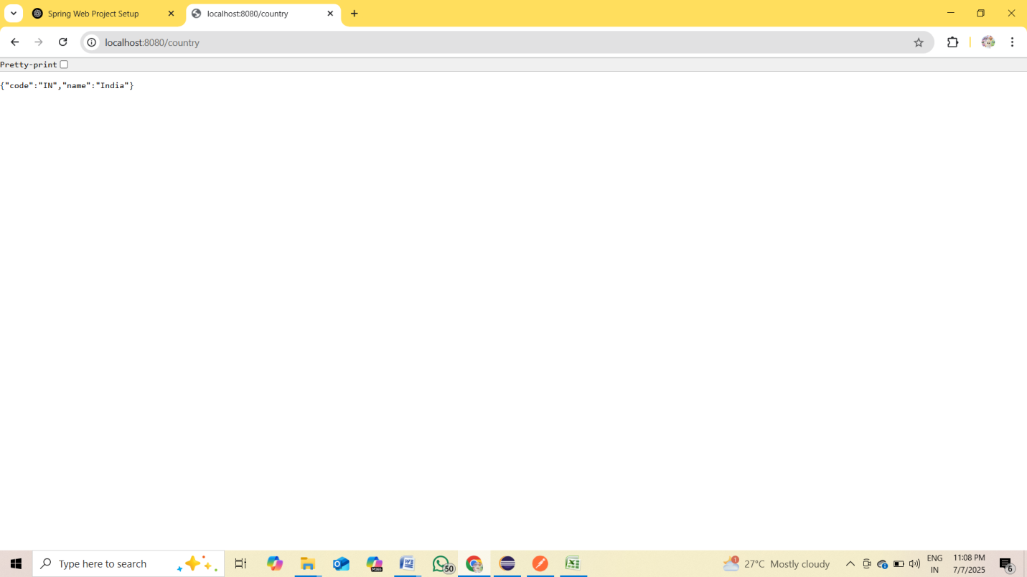

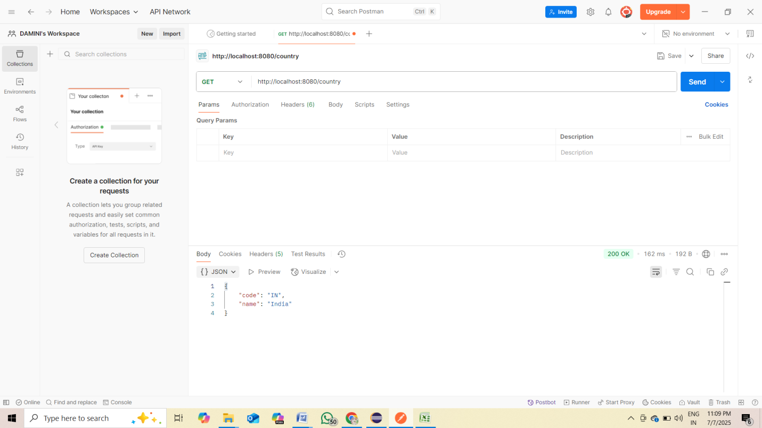

**Hands on**

**REST - Get country based on country code** 

**spring-learn/pom.xml**

<?xml version="1.0" encoding="UTF-8"?>

<project xmlns="http://maven.apache.org/POM/4.0.0" xmlns:xsi="http://www.w3.org/2001/XMLSchema-instance"

xsi:schemaLocation="http://maven.apache.org/POM/4.0.0 https://maven.apache.org/xsd/maven-4.0.0.xsd">

<modelVersion>4.0.0</modelVersion>

<parent>

<groupId>org.springframework.boot</groupId>

<artifactId>spring-boot-starter-parent</artifactId>

<version>3.5.3</version>

<relativePath/> <!-- lookup parent from repository -->

</parent>

<groupId>com.cognizant</groupId>

<artifactId>spring-learn</artifactId>

<version>0.0.1-SNAPSHOT</version>

<name>spring-learn</name>

<description>Demo project for Spring Boot</description>

<url/>

<licenses>

<license/>

</licenses>

<developers>

<developer/>

</developers>

<scm>

<connection/>

<developerConnection/>

<tag/>

<url/>

</scm>

<properties>

<java.version>17</java.version>

</properties>

<dependencies>

<dependency>

<groupId>org.springframework.boot</groupId>

<artifactId>spring-boot-starter-web</artifactId>

</dependency>

<dependency>

<groupId>org.springframework.boot</groupId>

<artifactId>spring-boot-devtools</artifactId>

<scope>runtime</scope>

<optional>true</optional>

</dependency>

<dependency>

<groupId>org.springframework.boot</groupId>

<artifactId>spring-boot-starter-test</artifactId>

<scope>test</scope>

</dependency>

</dependencies>

<build>

<plugins>

<plugin>

<groupId>org.springframework.boot</groupId>

<artifactId>spring-boot-maven-plugin</artifactId>

</plugin>

</plugins>

</build>

</project>

**SpringLearnAppicationTests.java**

**package** com.cognizant.spring_learn;

**import** org.junit.jupiter.api.Test;

**import** org.springframework.boot.test.context.SpringBootTest;

@SpringBootTest

**class** SpringLearnApplicationTests {

@Test

**void** contextLoads() {

}

}

**country.xml**

<?xml version="1.0" encoding="UTF-8"?>

<beans xmlns="http://www.springframework.org/schema/beans"

xmlns:xsi="http://www.w3.org/2001/XMLSchema-instance"

xsi:schemaLocation="

http://www.springframework.org/schema/beans

https://www.springframework.org/schema/beans/spring-beans.xsd">

<!-- SimpleDateFormat bean remains for earlier exercise -->

<bean id="dateFormat" class="java.text.SimpleDateFormat">

<constructor-arg value="dd/MM/yyyy" />

</bean>

<!-- List of countries -->

<bean id="countryList" class="java.util.ArrayList">

<constructor-arg>

<list>

<bean class="com.cognizant.springlearn.model.Country">

<property name="code" value="IN" />

<property name="name" value="India" />

</bean>

<bean class="com.cognizant.springlearn.model.Country">

<property name="code" value="US" />

<property name="name" value="United States" />

</bean>

<bean class="com.cognizant.springlearn.model.Country">

<property name="code" value="CN" />

<property name="name" value="China" />

</bean>

</list>

</constructor-arg>

</bean>

</beans>

**CountryService.java**

**package** com.cognizant.springlearn.service;

**import** java.util.List;

**import** org.slf4j.Logger;

**import** org.slf4j.LoggerFactory;

**import** org.springframework.context.ApplicationContext;

**import** org.springframework.context.support.ClassPathXmlApplicationContext;

**import** org.springframework.stereotype.Service;

**import** com.cognizant.springlearn.model.Country;

@Service

**public** **class** CountryService {

**private** **static** **final** Logger ***LOGGER*** = LoggerFactory.*getLogger*(CountryService.**class**);

**public** Country getCountry(String code) **throws** Exception {

***LOGGER***.info("START: getCountry() with code = {}", code);

ApplicationContext context = **new** ClassPathXmlApplicationContext("country.xml");

@SuppressWarnings("unchecked")

List<Country> countryList = (List<Country>) context.getBean("countryList");

// Case-insensitive search using lambda

**return** countryList.stream()

.filter(c -> c.getCode().equalsIgnoreCase(code))

.findFirst()

.orElseThrow(() -> **new** Exception("Country not found with code: " + code));

}

}

**SpringLearnAppication.java**

**package** com.cognizant.springlearn;

**import** java.text.ParseException;

**import** java.text.SimpleDateFormat;

**import** java.util.Date;

**import** org.slf4j.Logger;

**import** org.slf4j.LoggerFactory;

**import** org.springframework.boot.SpringApplication;

**import** org.springframework.boot.autoconfigure.SpringBootApplication;

**import** org.springframework.context.ApplicationContext;

**import** org.springframework.context.support.ClassPathXmlApplicationContext;

@SpringBootApplication

**public** **class** SpringLearnApplication {

**private** **static** **final** Logger ***LOGGER*** = LoggerFactory.*getLogger*(SpringLearnApplication.**class**);

**public** **static** **void** main(String[] args) {

***LOGGER***.info("Inside main");

SpringApplication.*run*(SpringLearnApplication.**class**, args);

*displayDate*();

}

**public** **static** **void** displayDate() {

ApplicationContext context = **new** ClassPathXmlApplicationContext("date-format.xml");

SimpleDateFormat format = context.getBean("dateFormat", SimpleDateFormat.**class**);

**try** {

Date date = format.parse("31/12/2018");

System.***out***.println("Parsed Date: " + date);

} **catch** (ParseException e) {

e.printStackTrace();

}

}

}

**HelloController.java**

**package** com.cognizant.springlearn.controller;

**import** org.slf4j.Logger;

**import** org.slf4j.LoggerFactory;

**import** org.springframework.web.bind.annotation.GetMapping;

**import** org.springframework.web.bind.annotation.RestController;

@RestController

**public** **class** HelloController {

**private** **static** **final** Logger ***LOGGER*** = LoggerFactory.*getLogger*(HelloController.**class**);

@GetMapping("/hello")

**public** String sayHello() {

***LOGGER***.info("START: sayHello()");

String message = "Hello World!!";

***LOGGER***.info("END: sayHello()");

**return** message;

}

}

**Country.java**

**package** com.cognizant.springlearn.model;

**public** **class** Country {

**private** String code;

**private** String name;

// Default constructor

**public** Country() {

}

// Parameterized constructor

**public** Country(String code, String name) {

**this**.code = code;

**this**.name = name;

}

// Getters and setters

**public** String getCode() {

**return** code;

}

**public** **void** setCode(String code) {

**this**.code = code;

}

**public** String getName() {

**return** name;

}

**public** **void** setName(String name) {

**this**.name = name;

}

}

**CountryController.java**

**package** com.cognizant.springlearn.controller;

**import** org.slf4j.Logger;

**import** org.slf4j.LoggerFactory;

**import** org.springframework.beans.factory.annotation.Autowired;

**import** org.springframework.context.ApplicationContext;

**import** org.springframework.context.support.ClassPathXmlApplicationContext;

**import** org.springframework.web.bind.annotation.GetMapping;

**import** org.springframework.web.bind.annotation.PathVariable;

**import** org.springframework.web.bind.annotation.RequestMapping;

**import** org.springframework.web.bind.annotation.RestController;

**import** com.cognizant.springlearn.model.Country;

**import** com.cognizant.springlearn.service.CountryService;

@RestController

**public** **class** CountryController {

**private** **static** **final** Logger ***LOGGER*** = LoggerFactory.*getLogger*(CountryController.**class**);

@Autowired

**private** CountryService countryService;

@RequestMapping("/country")

**public** Country getCountryIndia() {

***LOGGER***.info("START: getCountryIndia()");

ApplicationContext context = **new** ClassPathXmlApplicationContext("country.xml");

Country country = context.getBean("country", Country.**class**);

***LOGGER***.info("END: getCountryIndia()");

**return** country;

}

@GetMapping("/countries/{code}")

**public** Country getCountry(@PathVariable String code) **throws** Exception {

***LOGGER***.info("START: getCountry() Controller with code = {}", code);

Country country = countryService.getCountry(code);

***LOGGER***.info("END: getCountry() Controller");

**return** country;

}

}

**OUTPUT**

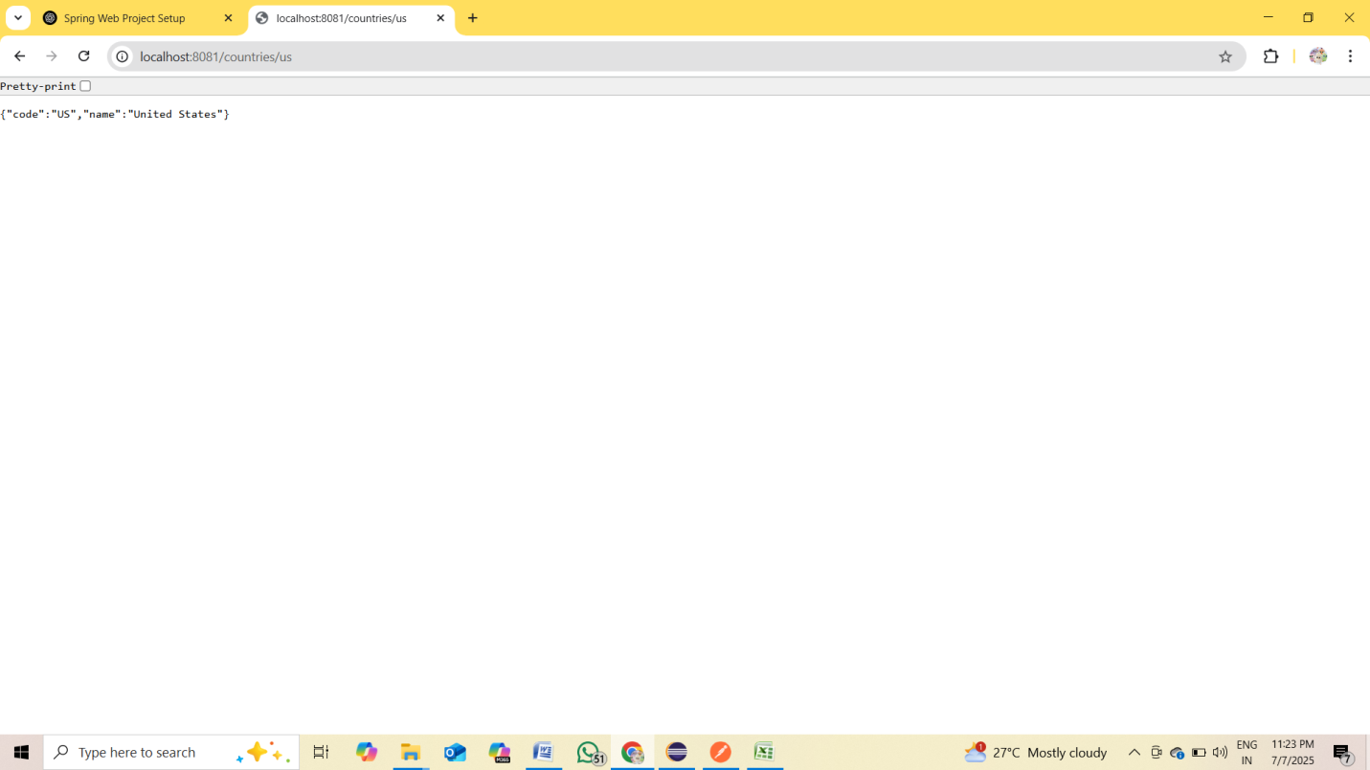

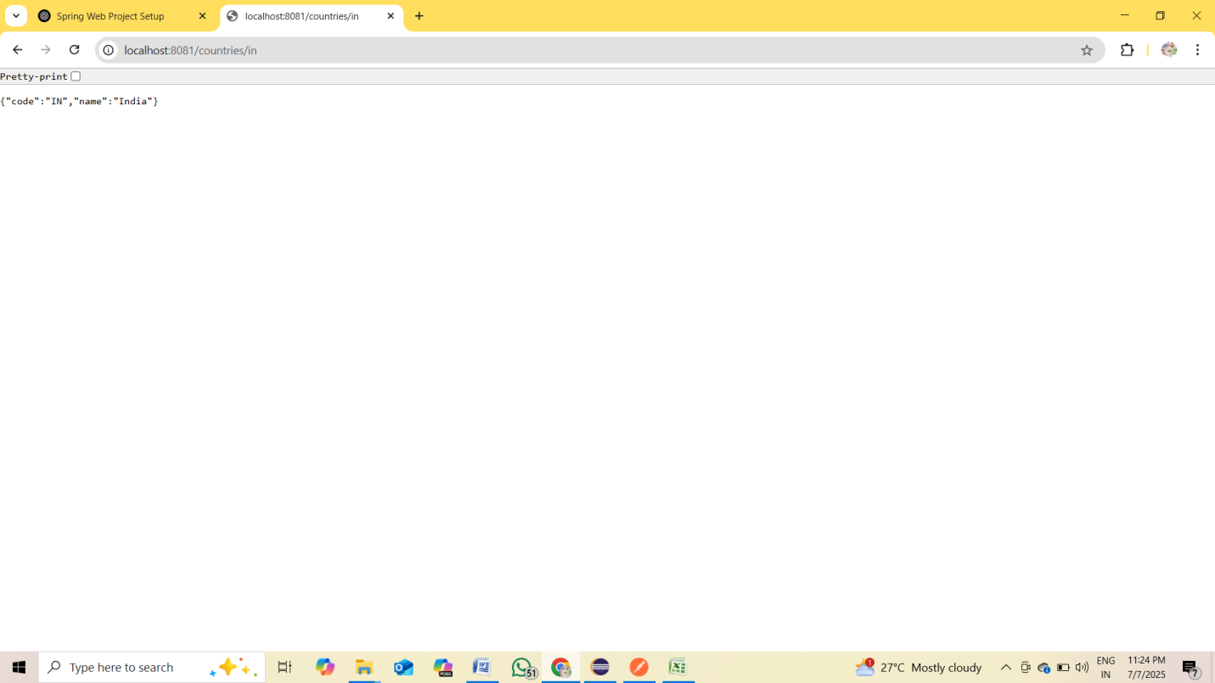

**Hands-on**

**Create authentication service that returns JWT**

**spring-learn/pom.xml**

<project xmlns="http://maven.apache.org/POM/4.0.0"

xmlns:xsi="http://www.w3.org/2001/XMLSchema-instance"

xsi:schemaLocation="http://maven.apache.org/POM/4.0.0

http://maven.apache.org/xsd/maven-4.0.0.xsd">

<modelVersion>4.0.0</modelVersion>

<groupId>com.cognizant</groupId>

<artifactId>spring-learn</artifactId>

<version>0.0.1-SNAPSHOT</version>

<packaging>jar</packaging>

<name>spring-learn</name>

<description>Spring Learn Application</description>

<parent>

<groupId>org.springframework.boot</groupId>

<artifactId>spring-boot-starter-parent</artifactId>

<version>3.2.2</version> <!-- Or your preferred Spring Boot version -->

<relativePath/> <!-- lookup parent from repository -->

</parent>

<properties>

<java.version>17</java.version>

</properties>

<dependencies>

<dependency>

<groupId>org.springframework.boot</groupId>

<artifactId>spring-boot-starter-web</artifactId>

</dependency>

<dependency>

<groupId>org.springframework.boot</groupId>

<artifactId>spring-boot-starter-security</artifactId>

</dependency>

<dependency>

<groupId>io.jsonwebtoken</groupId>

<artifactId>jjwt-api</artifactId>

<version>0.11.5</version>

</dependency>

<dependency>

<groupId>io.jsonwebtoken</groupId>

<artifactId>jjwt-impl</artifactId>

<version>0.11.5</version>

<scope>runtime</scope>

</dependency>

<dependency>

<groupId>io.jsonwebtoken</groupId>

<artifactId>jjwt-jackson</artifactId>

<version>0.11.5</version>

<scope>runtime</scope>

</dependency>

<dependency>

<groupId>org.springframework.boot</groupId>

<artifactId>spring-boot-starter-logging</artifactId>

</dependency>

</dependencies>

<build>

<plugins>

<plugin>

<groupId>org.springframework.boot</groupId>

<artifactId>spring-boot-maven-plugin</artifactId>

</plugin>

</plugins>

</build>

</project>

**SecurityConfig**

**package** com.cognizant.springlearn.config;

**import** org.springframework.context.annotation.Bean;

**import** org.springframework.context.annotation.Configuration;

**import** org.springframework.security.config.Customizer;

**import** org.springframework.security.config.annotation.web.configuration.EnableWebSecurity;

**import** org.springframework.security.web.SecurityFilterChain;

**import** **static** org.springframework.security.config.Customizer.*withDefaults*;

**import** org.springframework.security.config.annotation.web.builders.HttpSecurity;

@Configuration

@EnableWebSecurity

**public** **class** SecurityConfig {

@Bean

**public** SecurityFilterChain filterChain(HttpSecurity http) **throws** Exception {

http

.csrf(csrf -> csrf.disable())

.authorizeHttpRequests(auth -> auth

.requestMatchers("/authenticate").permitAll()

.anyRequest().authenticated()

)

.httpBasic(*withDefaults*());

**return** http.build();

}

}

**AuthenticationController**

**package** com.cognizant.springlearn.controller;

**import** io.jsonwebtoken.Jwts;

**import** io.jsonwebtoken.SignatureAlgorithm;

**import** io.jsonwebtoken.security.Keys;

**import** org.springframework.http.HttpHeaders;

**import** org.springframework.http.ResponseEntity;

**import** org.springframework.web.bind.annotation.*;

**import** java.nio.charset.StandardCharsets;

**import** java.security.Key;

**import** java.util.Base64;

**import** java.util.Date;

**import** java.util.HashMap;

**import** java.util.Map;

@RestController

**public** **class** AuthenticationController {

**private** **static** **final** String ***SECRET_KEY*** = "mySuperSecretKeyForJwtSigning12345";

@RequestMapping(value = "/authenticate", method = RequestMethod.***GET***)

**public** ResponseEntity<Map<String, String>> authenticate(@RequestHeader(HttpHeaders.***AUTHORIZATION***) String authHeader) {

// Decode Basic Auth

**if** (authHeader == **null** || !authHeader.startsWith("Basic ")) {

**return** ResponseEntity.*status*(401).build();

}

String base64Credentials = authHeader.substring("Basic ".length());

String credentials = **new** String(Base64.*getDecoder*().decode(base64Credentials), StandardCharsets.***UTF_8***);

String[] values = credentials.split(":", 2);

**if** (values.length != 2) {

**return** ResponseEntity.*status*(400).build();

}

String username = values[0];

String password = values[1];

// Very simple check (in real apps use UserDetailsService!)

**if** (!"user".equals(username) || !"pwd".equals(password)) {

**return** ResponseEntity.*status*(401).build();

}

// Generate JWT

Key key = Keys.*hmacShaKeyFor*(***SECRET_KEY***.getBytes(StandardCharsets.***UTF_8***));

String jwt = Jwts.*builder*()

.setSubject(username)

.setIssuedAt(**new** Date(System.*currentTimeMillis*()))

.setExpiration(**new** Date(System.*currentTimeMillis*() + 1000 * 60 * 10)) // 10 minutes

.signWith(key, SignatureAlgorithm.***HS256***)

.compact();

Map<String, String> response = **new** HashMap<>();

response.put("token", jwt);

**return** ResponseEntity.*ok*(response);

}

}

**SpringLearnApplication**

**package** com.cognizant.springlearn;

**import** org.slf4j.Logger;

**import** org.slf4j.LoggerFactory;

**import** org.springframework.boot.SpringApplication;

**import** org.springframework.boot.autoconfigure.SpringBootApplication;

@SpringBootApplication

**public** **class** SpringLearnApplication {

**private** **static** **final** Logger ***LOGGER*** = LoggerFactory.*getLogger*(SpringLearnApplication.**class**);

**public** **static** **void** main(String[] args) {

***LOGGER***.info("Inside main()");

SpringApplication.*run*(SpringLearnApplication.**class**, args);

}

}

**OUTPUT**

